**Simulation :** CMOS

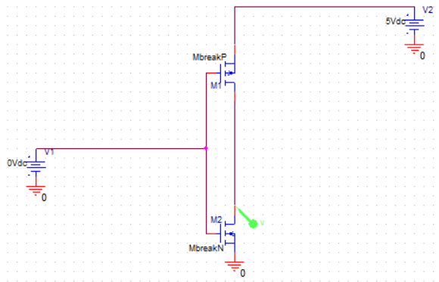

**Figure :** Circuit Diagram for CMOS.

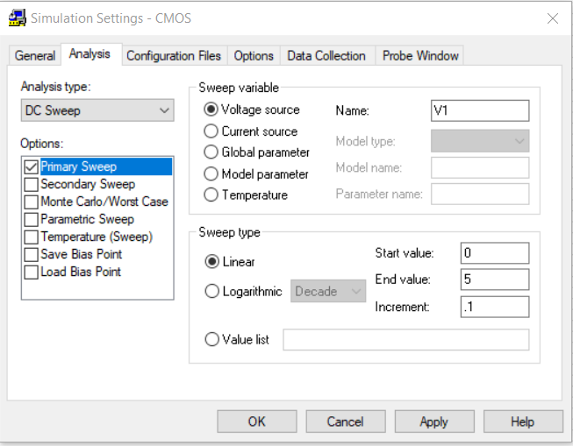

**Figure :** Input for CMOS.

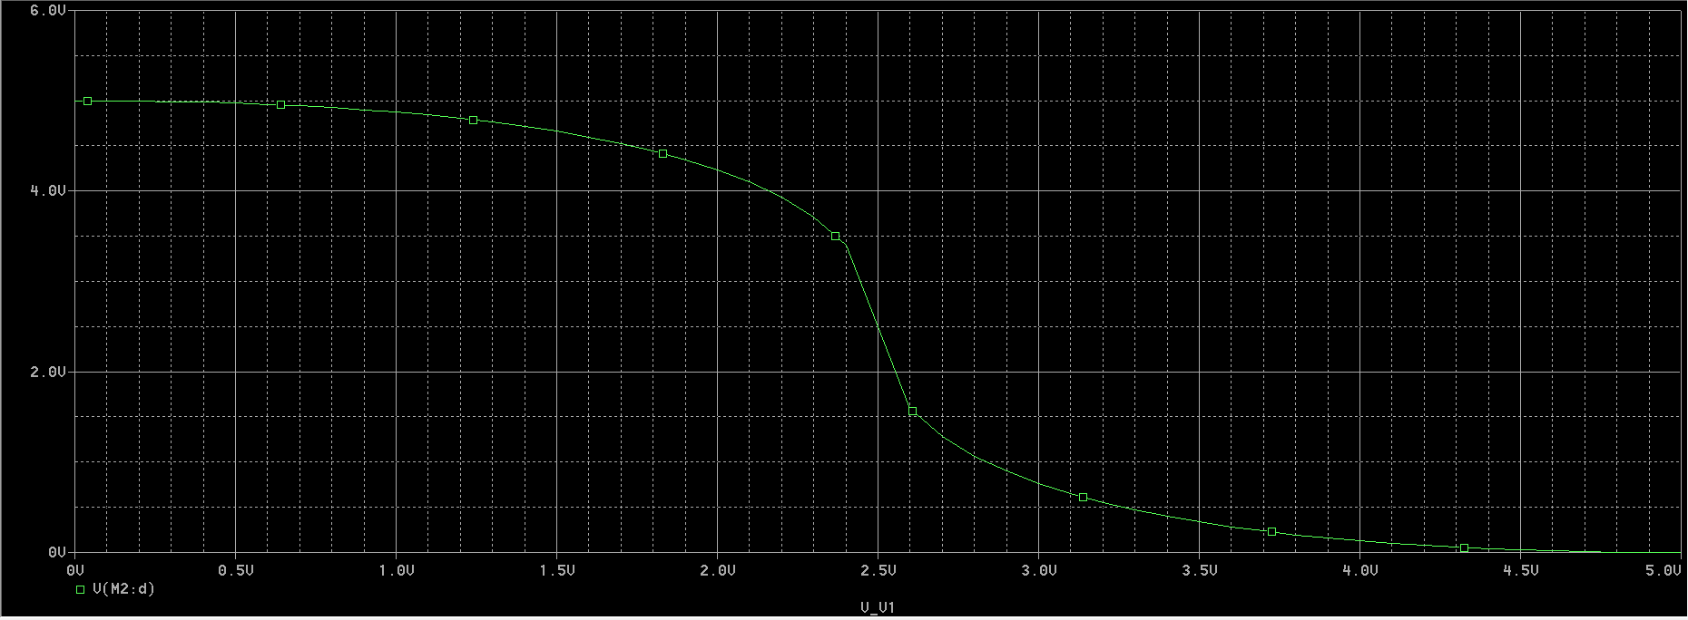

**Figure :** Resultant Curve for CMOS.